DECISION TREE

Uncertainty is 100% when both classification output is 50% 1 and 50% 0

For example, for fair coin 50% head and 50% tail.

For Uncertainty is less than 100% means it is unfair coin

If it is 100% uncertainty then 0% accuracy/prob if it is 0% uncertainty it is 100%accuracy. If it is 50%accuracy it is 100% uncertainty for both equal 0 and 1’s classification output.

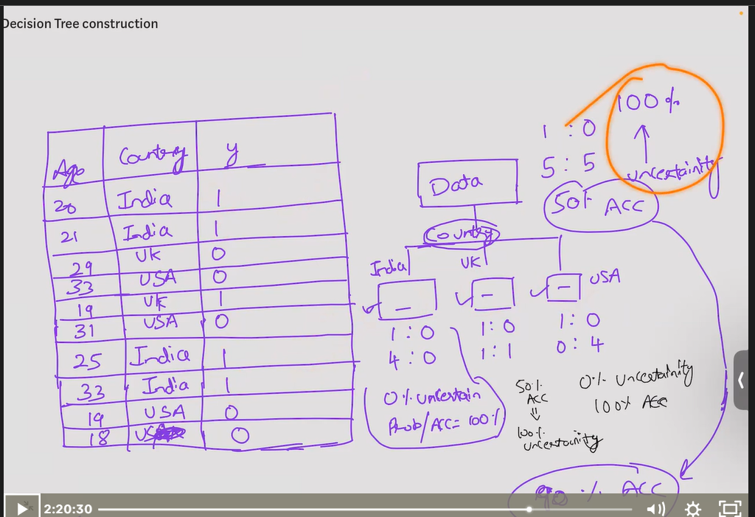

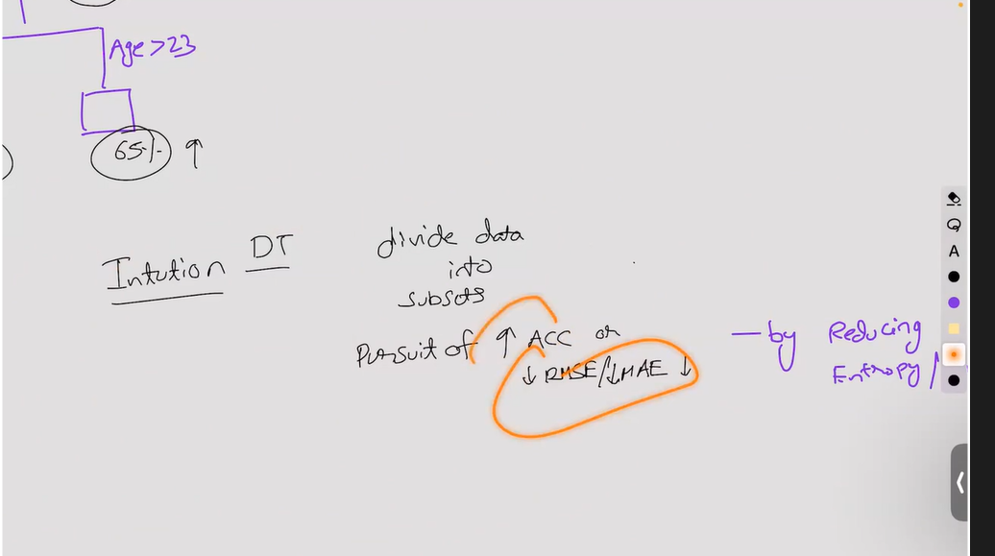

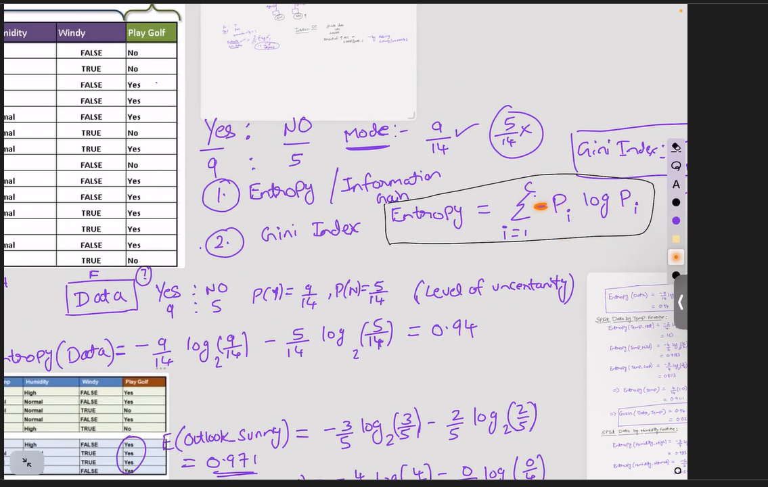

Entropy means incertainty

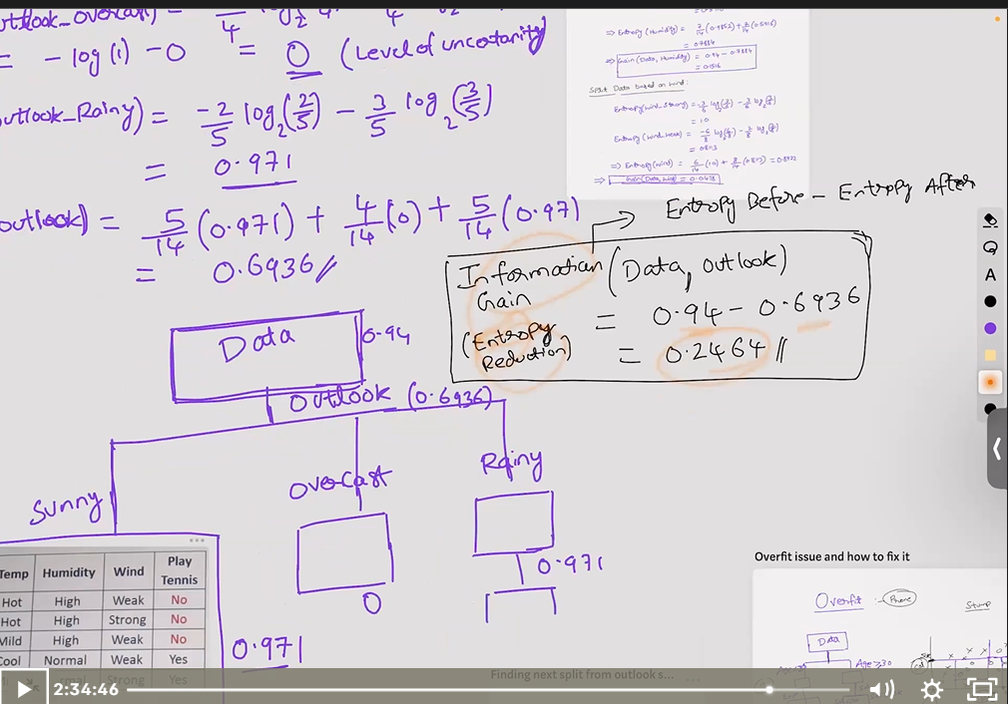

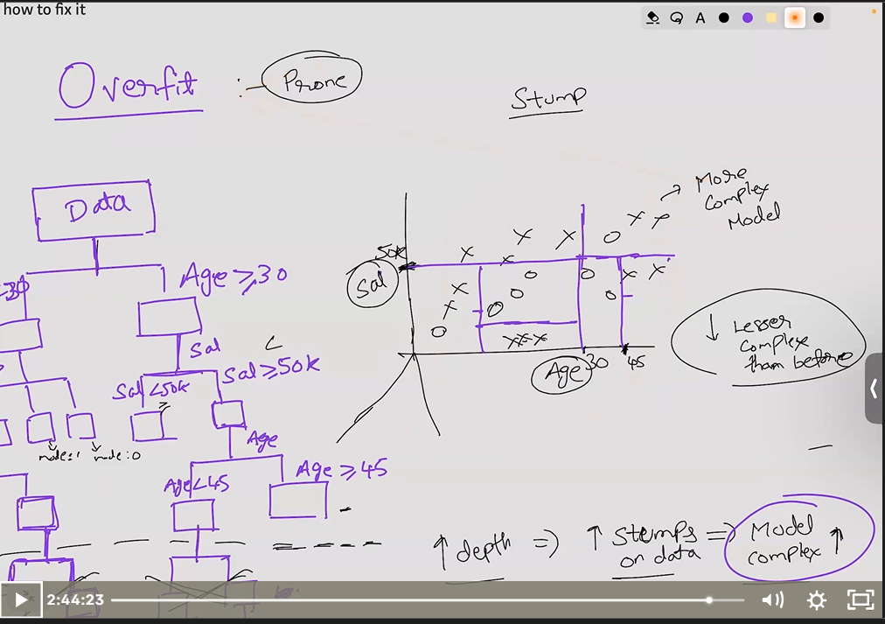

Here we reduce stump to avoid overfit likewise we did in linear regression for polyamial we reduce coefficient right simularley.

Why decision tree is prone to overfit?

Beacuase it keep on split the tree until the uncertainty is 0% and accuracy is 100%.